Ex. No.: 1 Date:
Register No.: 241701013 Name: DHANESH SK
Create a Study Focus Tracker Application using a Timer and Data Storage
AIM: To develop a simple Study Focus Tracker application that utilizes a GUI (Graphical User Interface) with:
- A timer to set and run focused study sessions.
- The ability to record and save session data (subject and duration) to a JSON file.
- A stats display to show the total study time for the current day.
Procedure:
- Use the Python GUI framework tkinter for the user interface.
- Implement a function to read and write session data to a JSON file (study_data.json) using the json module.
- Create a countdown function to handle the timer logic and update the display every second using root.after().
- Design the GUI with input fields for Subject and Duration (in minutes).
- Include a "Start Timer" button to initiate the session.
- Implement a show_stats function to calculate and display the total study time for the current day.
Program:Python
import tkinter as tk
from tkinter import messagebox
import time, json, math
from datetime import date
try:
with open("study_data.json", "r") as f:
study_data = json.load(f)
except:
study_data = {}

def save_session(subject, duration):
today = str(date.today())
if today not in study_data:
study_data[today] = []
study_data[today].append({"subject": subject, "duration": duration})
with open("study_data.json", "w") as f:
json.dump(study_data, f, indent=4)

def start_timer():
subject = subject_entry.get()
try:
duration = int(duration_entry.get())
countdown(duration * 60, subject)
except ValueError:
messagebox.showerror("Input Error", "Duration must be an integer!")

def countdown(seconds, subject):
if seconds > 0:
mins = seconds // 60
secs = seconds % 60
timer_label.config(text=f"{mins:02d}:{secs:02d}")
root.after(1000, countdown, seconds - 1, subject)
else:
messagebox.showinfo("Done!", "Session Complete! Take a break 😊")
save_session(subject, int(duration_entry.get()))
show_stats()

def show_stats():
today = str(date.today())
if today in study_data:
total = sum([x['duration'] for x in study_data[today]])
hrs = math.floor(total / 60)
mins = total % 60
stats_label.config(text=f"Total Study Today: {hrs}h {mins}m")
else:
stats_label.config(text="No sessions today yet!")

root = tk.Tk()
root.title("Study Focus Tracker")

tk.Label(root, text="Subject:").pack()
subject_entry = tk.Entry(root)
subject_entry.pack()

tk.Label(root, text="Duration (mins):").pack()
duration_entry = tk.Entry(root)
duration_entry.pack()

tk.Button(root, text="Start Timer", command=start_timer).pack(pady=5)
timer_label = tk.Label(root, text="00:00", font=("Helvetica", 24))
timer_label.pack()

stats_label = tk.Label(root, text="Total Study Today: 0h 0m")
stats_label.pack(pady=10)

show_stats() # Load initial stats
root.mainloop()

Output:

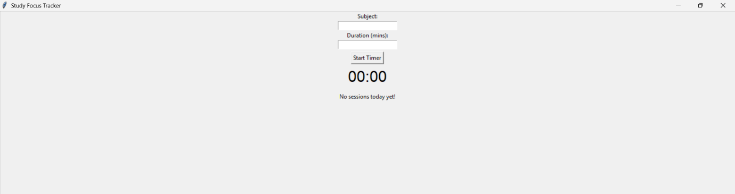

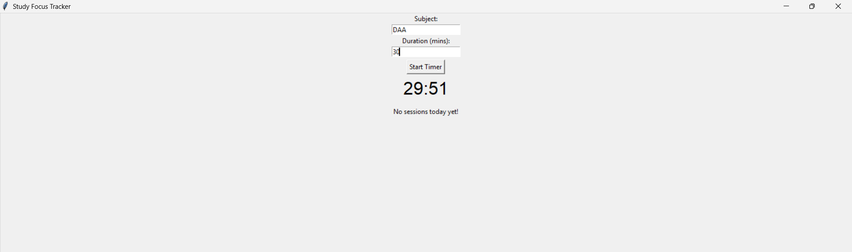

Result:
A Study Focus Tracker application was successfully created using Python's tkinter library. It includes a functional timer for focused work sessions, saves session details to a JSON file, and displays the total study time accumulated for the current day.

